
+-

Chemical Reactions:
reactants, products and energy change
TEACHER
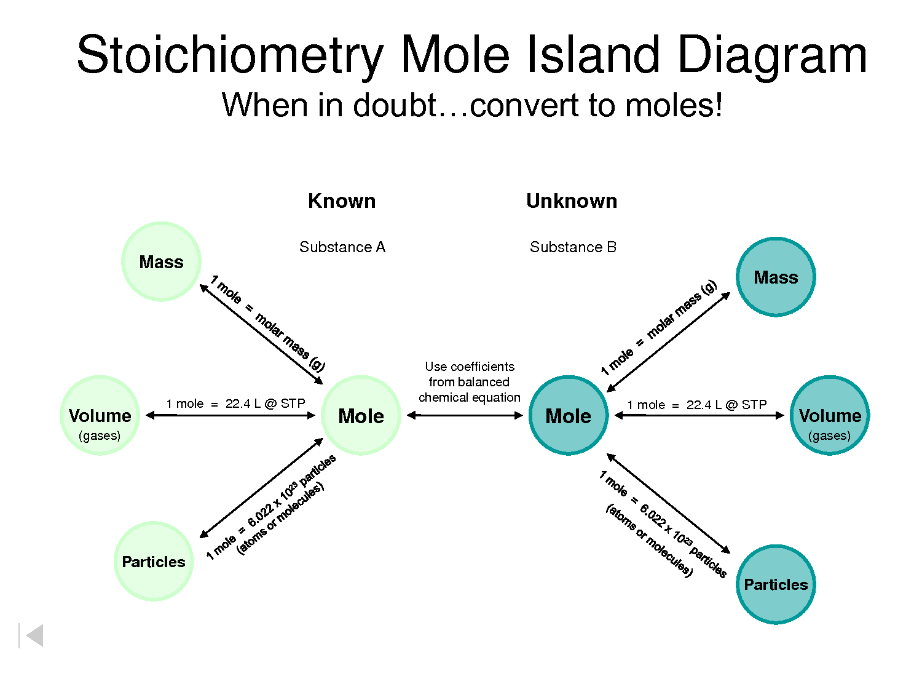
(Chemtutor n.d.)

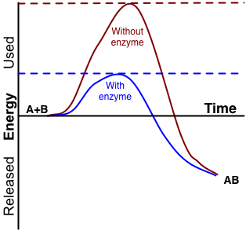
(Biochemistry/Catalysis n.d.)

Week | Outcomes | References | Tasks
Term 2  Week 1-3 | - chemical reactions can be represented by chemical equations; balanced chemical equations indicate the relative numbers of particles (atoms, molecules or ions) that are involved in the reaction  - chemical reactions and phase changes involve enthalpy changes, commonly observable as changes in the temperature of the surroundings and/or the emission of light  - endothermic and exothermic reactions can be explained in terms of the Law of Conservation of Energy and the breaking of existing bonds and forming of new bonds; heat energy released or absorbed by the system to or from the surroundings, can be represented in thermochemical equations  - fossil fuels (including coal, oil, petroleum and natural gas) and biofuels (including biogas, biodiesel and bioethanol) can be compared in terms of their energy output, suitability for purpose, and the nature of products of combustion  - the mole is a precisely defined quantity of matter equal to Avogadro’s number of particles  - the mole concept relates mass, moles and molar mass and, with the Law of Conservation of Mass; can be used to calculate the masses of reactants and products in a chemical reaction  - empirical formula can be determined using percentage composition, mass composition and combustion data | Lucarelli p 45 Set 8  Lucarelli p 100 -108 Set 22 Q1-9  Lucarelli p 77 - 80 Set 16 Q1-5  Lucarelli p 81- 82 Set 17 Q1-12  Lucarelli p 86 - 88 Set 19 Q1-6 | STAWA Experiment 21  STAWA Experiment 35
4-6 | REVISION AND EXAMS
7-8 | - the limiting reagent in a chemical reaction can be determined using masses and moles of reactants |  | Task 8: Extended response 2- Energy and CO₂ output for fossil fuels and biofuels  Task 9: Test- Chemical Reactions: Reactants, Products and Energy Change

Insert Lucarelli pg 43 and 44

Write balanced chemical equations of the following for more practice.
1. Hydrogen + oxygen water
2. Carbon + oxygen carbon dioxide
3. Sodium + chlorine sodium chloride
4. Potassium + oxygen potassium oxide
5. Magnesium + oxygen magnesium oxide
6. Magnesium + hydrochloric acid magnesium chloride + hydrogen
7. Ammonia + water ammonium hydroxide
8. Zinc + hydrochloric acid zinc chloride + hydrogen
9. Sodium + sulfuric acid sodium sulfate + hydrogen
10. Calcium carbonate + hydrochloric acid calcium chloride + water + carbon dioxide
11. Hydrogen + nitrogen ammonia
12. Aluminium + oxygen aluminium oxide
13. Calcium oxide + water calcium hydroxide
14. Calcium hydroxide + carbon dioxide calcium carbonate + water
15. Ammonia + sulfuric acid ammonium sulfate
16. Silver nitrate + magnesium chloride silver chloride + magnesium nitrate
17. Potassium nitrate potassium nitrite + oxygen
18. Sodium hydroxide + carbon dioxide sodium carbonate + water
19. Potassium hydrogen carbonate potassium carbonate + water + carbon dioxide
20. Zinc + silver nitrate zinc nitrate + silver
21. sodium permanganate + sulfuric acid + hydrogen peroxide
manganese sulfate + sodium sulfate + oxygen + water
22. sodium thiosulfate (Na₂S₂O₃) + potassium dichromate + hydrogen chloride
sulfur + sodium sulfate + chromium chloride + potassium chloride + water

Chemical equation answers
1. 2H_{2(g)} + O_{2(g)} → 2H₂O_{(l)}
2. C_{(s)} + O_{2(g)} → CO_{2(g)}
3. 2Na_{(s)} + Cl_{2(g)} → 2NaCl_{(s)}
4. 2K_{(s)} + O_{2(g)} → 2K₂O_{(s)}
5. 2Mg_{(s)} + O_{2(g)} → 2MgO_{(s)}
6. Mg_{(s)} + 2HCl_{(aq)} → MgCl_{2(aq)} + H_{2(g)}
7. NH_{3(g)} + H₂O_{(l)} → NH₄OH_{(aq)}
8. Zn_{(s)} + 2HCl_{(aq)} → ZnCl_{2(aq)} + H_{2(g)}
9. 2Na_{(s)} + H₂SO_{4(aq)} → Na₂SO_{4(aq)} + H_{2(g)}
10. CaCO_{3(s)} + 2HCl_{(aq)} → CaCl_{2(aq)} + H₂O_{(l)} + CO_{2(g)}
11. 3H_{2(g)} + N_{2(g)} → 2NH_{3(g)}
12. 4Al_{(s)} + 3O_{2(g)} → 2Al₂O_{3(s)}
13. CaO_{(s)} + H₂O_{(l)} → Ca(OH)_{2(aq)}
14. Ca(OH)_{2(aq)} + CO_{2(g)} → CaCO_{3(s)} + H₂O_{(l)}
15. 2NH_{3(g)} + H₂SO_{4(aq)} → (NH₄)₂SO_{4(aq)}
16. 2AgNO_{3(aq)} + MgCl_{2(aq)} → 2AgCl_{(s)} + Mg(NO₃)_{2(aq)}
17. 2KNO_{3(s)} → 2KNO_{2(s)} + O_{2(g)}
18. 2NaOH_{(s)} + CO_{2(g)} → Na₂CO_{3(aq)} + H₂O_{(l)}
19. 2KHCO_{3(s)} → K₂CO_{3(s)} + H₂O_{(g)} + CO_{2(g)}
20. Zn_{(s)} + 2AgNO_{3(aq)} → Zn(NO₃)_{2(aq)} + 2Ag_{(s)}
21. 4NaMnO_{4(aq)}+ 2H₂O_{2(l)} + 4H₂SO_{4(aq)} → 2MnSO_{4(aq)} + 2Na₂SO_{4(aq)} + 7O_{2(g)} + 6H₂O_{(l)}
22. 3Na₂S₂O_{3(aq)} + K₂Cr₂O_{7(aq)} + 8HCl_{(aq)} 3S_{(s)} + 3Na₂SO₄ _{(aq)}+ 2CrCl_{3(aq)} + 2KCl_{(aq)} + 4H₂O_{(l)}
ENDOTHERMIC AND EXOTHERMIC REACTIONS (pg 101)
All chemical reactions involve energy changes. Energy can be either gained or released by both the reactants or the products. This follows the law of conservation of energy which states that energy cannot be created or destroyed, merely converted from one form to another or transferred from one object to another.
Terms:
- Enthalpy (H): the total energy (both chemical potential energy and kinetic energy) present in a substance.
- ΔH (enthalpy change): difference between the enthalpy of products and the enthalpy of reactants. The difference between the energy gained (absorbed/ taken in/ required) and the energy released. ΔH = H_{products} - H_{reactants}
- System: the collection of atoms, molecules or ions involved in a chemical reaction e.g. the ions in a precipitation reaction.
- Surroundings: anything around the system, but not part of the system e.g. the solvent in a precipitation reaction, the test tube, your hand.

ENERGY PROFILE DIAGRAMS FOR EXOTHERMIC AND ENDOTHERMIC REACTIONS
The release or gain of energy can be represented in diagrams where reaction time is plotted against enthalpy. Note that total energy is always conserved, despite the change in energy of a substance as shown in these diagrams – copy from Essential Chemistry pg 114

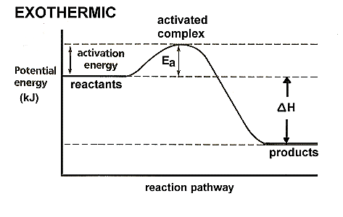
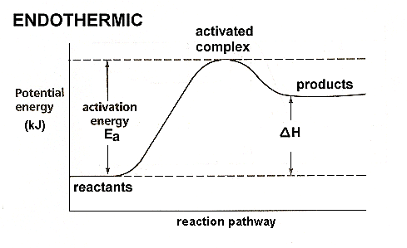

Exothermic Reactions
- More energy is released in forming bonds than is required to break the initial bonds, so the reaction releases energy to the surroundings. (Bond forming releases energy, bond breaking requires energy. The stronger the bonds that are formed, the greater the energy released in forming them.)
- Enthalpy of products is less than reactants.
- Reactants have a higher chemical energy than the products.
- ΔH is negative.
- Enthalpy decreases for the system and increases for the surroundings.
- Energy is released from the system to the surroundings in the form of heat, light, etc.
- The surroundings will gain heat.

Examples of exothermic processes
- Combustion: CH_{4(g)} + 2O_{2(g)} → CO_{2(g)} + 2H₂O_{(g)} + 803 kJ OR
CH_{4(g)} + 2O_{2(g)} → CO_{2(g)} + 2H₂O_{(g)} ΔH = – 803 kJ
- Reactions involving single atoms bonding together: 2I_{(g)} → I_{2(g)} + 214 kJ
- Reactions in which a positive ion gains an electron: Na⁺_{(g)} + e⁻ → Na_{(g)}
- Condensation and solidification (freezing) phase changes: I_{2(g)} → I_{2(s)} + 62 kJ
H₂O_{(g)} → H₂O_{(l)} ΔH = –44 kJ
- Respiration: C₆H₁₂O_{6(aq)} + 6O_{2(g)} → 6CO_{2(g)} + 6H₂O_{(l)}
- Heat packs
– non-reversible: 4Fe_{(s)} + 3O_{2(g)} → 2Fe₂O_{3(s)} ΔH = – 1654 kJ OR
– reversible: NaCH₃COO_{(aq)} + 3H₂O_{(l)} ⇋ NaCH₃COO.3H₂O_{(s)}
- Crystallisation

Phase changes are physical processes that involve the breaking and forming of bonds but of weak bonds only like weak intermolecular forces between iodine molecules during sublimation. By comparison chemical changes involve the breaking and forming of strong intramolecular bonds like covalent bonds in the iodine molecule. For this reason, phase changes usually involve relatively small amounts of energy compared to chemical changes.

In general, chemical processes involve greater enthalpy changes than physical processes. This is due to the fact that the intermolecular forces are usually weaker than the intramolecular forces.

Endothermic reactions
- More energy is required in breaking the initial bonds than is released in forming bonds so the reaction absorbs energy from the surroundings. (Bond forming releases energy, bond breaking requires energy. The stronger the bonds that are broken, the greater the energy required to break them)
- Enthalpy of products is greater than reactants.
- Reactants have a lower chemical energy than the products.
- ΔH is positive.
- Enthalpy increases for the system and decreases for the surroundings.
- Energy is absorbed from the surroundings to the system.
- The surroundings will lose heat.

Examples of endothermic processes:

- Reactions involving a molecule breaking up: F_{2(g)} → 2F_{(g)} ΔH = + 158 kJ
- Reactions in which an atom or ion loses an electron: K_{(g)} → K⁺_{(g)} + e⁻
- Melting and evaporation phase changes.
- Photosynthesis: 6CO_{2(g)} + 6H₂O_{(l)} → C₆H₁₂O_{6(aq)} + 6O_{2(g)}
- Cold packs (older style involving ammonium nitrate dissolving in water)
- NH₄NO_{3(s)} + 126 kJ→ NH₄⁺_{(aq)} + NO₃–_{(aq)} OR
- NH₄NO_{3(s)} → NH₄⁺_{(aq)} + NO₃–_{(aq)} ΔH = +126 kJ

Comparing fossil fuels: emissions and fuel values.
Fuel values (sometimes called heating values): compare the energy from the complete combustion of equal masses or volumes of different fuels. The greater the value the greater the energy available from a given mass. Units in kJ g⁻¹, MJ kg⁻¹, MJ L⁻¹
x = $\frac{ ΔHc}{M}$ Where $ΔHc$ = standard heat of combustion of 1 mol of the fuel. M = molar mass
Carbon emissions: Combustion of fuels release carbon dioxide, which is a known greenhouse gas, into the atmosphere.
Carbon emission values: compare the mass of carbon dioxide a given fuel produces with the amount of energy released. Units in g MJ⁻¹.
Fill in the values for the table below from Essential Chemistry pg 105.
 | Heating value  MJ.kg⁻¹ | Carbon emissions  g(CO₂)MJ⁻¹
Coal | 27 | 92
Natural gas | 47 | 51
LNG | 49 | 51
LPG | 49 | 59
Petrol | 46 | 66
Diesel | 46 | 70

Biofuels
Biofuels are fuels that are produced from biodegradeable materials such as crops rather than from fossil fuels. Examples of biofuels include: bioethanol, biogas and biodiesel.
Advantages of biofuels are that they: are made from a renewable resource, they have lower carbon emissions and they have extremely low sulphur content meaning there is no SO₂ formation that can lead to acid rain.
Bioethanol is produced from the fermentation of plant sugars (such as in wheat and sugar cane) to ethanol by yeast.
Biodiesel is produced by the transesterification of oilseed crops.

Significant Figures and Rounding

The rules for determining the number of significant figures are (Essential Chemistry pg 39):

- All non- zero digits are significant.
Eg 7.92 3sf

- Zeros between two significant digits are significant.
Eg 7.092 4sf
92.0001 6sf

- Zeros before the first non-zero digit are not significant.
Eg 0.035 2sf
0.0006 1sf

- Zeros at the end of a number and after the decimal point are significant
Eg 7.92000 6sf
518.0 4sf

- Zeros at the end of a number and before a decimal point are not significant unless otherwise indicated
Eg 45000 2sf
8000000 1sf
4730 3sf

If any of the zeros are significant then you will have to use Scientific notation to show this.
Eg 4.5000 x 10⁴ 5sf
4.500 x 10⁴ 4sf
4.50 x 10⁴ 3sf
4.5 x 10⁴ 2sf

8.000000 x 10⁶ 7sf
etc

4.730 4sf
etc

Empirical formula
Empirical formula can be calculated using:
- Mass data
- Percentage composition
- Combustion data

a) A compound was analysed and found to contain by mass 4.659 g silver and 0.347 g oxygen.
Determine its empirical formula.
 | Ag | O
m | 4.659 | 0.347
n | 4.659/107.9  = 0.0432 | 0.347/16.00  = 0.0217
Ratio | 0.0432/0.0217  = 1.99  = 2 | 0.0217/0.0217  = 1

Empirical formula: Ag₂O

b) An unidentified compound was analysed in the laboratory and found to have the following percentage composition by mass: Carbon 26.09%, Hydrogen 4.35%, Oxygen 69.56%. What is the empirical formula?
 | C | H | O
% | 26.06 | 4.35 | 69.56
m | 26.06 | 4.35 | 69.56
n | 26.06/12.01  = 2.17 | 4.35/1.008  = 4.32 | 69.56/16.00  = 4.35
Ratio | 2.17/2.17  = 1.00 | 4.32/2.17  = 2.00 | 4.35/2.17  = 2.00

Empirical formula: CH₂O₂

(Remember also how to calculate percentage composition of a compound eg Calculate the percentage composition of each element in Al(NO₃)_{3.}
M = (26.98) + (14.01 x 3) + (16.00 x 9) = 213.01 gmol⁻¹
% Al = 26.98/ 213.01 x 100 = 12.67 %
% N = (14.01 x 3)/ 213.01 x 100 = 19.73 %
% O = (16.00 x 9)/ 213.01 x 100 = 67.60 %

- A white crystalline solid of molecular formula C_{x}H_{y}O_{z} was isolated from certain fruits. When 0.682 g of the compound was combusted with oxygen gas, it produced 0.968 g of carbon dioxide gas and 0.594 g of water. Determine the empirical formula and, hence, the molecular formula of the substance if it has a molecular mass of 62.3 g mol⁻¹.

C_{x}H_{y}O_{z} + O₂ X CO₂ + Y/2 H₂O

 | C | H | O
Ratio | n_{CO2} = 0.968/ 44.01  = 0.0220 mol  n_{C} = n_{CO2} = 0.0220 mol  m_{C} = (0.0220) (12.01)  = 0.264 g  0.0220/ 0.0220  = 1 | n_{H2O} = 0.594/ 18.016  = 0.0330 mol  n_{H} = n_{H2O} x 2 = 0.0659 mol  m_{H} = (0.0659) (1.008)  = 0.0665 g  0.0659/ 0.0220  = 3 | m_{O} = 0.682 – (0.264 + 0.0665)  = 0.351 g  n_{O} = 0.351/ 16.00  = 0.0220 mol  0.0220/0.0220  = 1

Empirical formula = CH₃O

Molecular formula = (Molar mass/ Empirical formula mass) x CH₃O
= 62.3/ 31.034 x CH₃O
= 2 x CH₃O

Molecular formula = C₂H₆O₂

Avogadro's number (N)

Avogadro's number is 6.022 x 10²³ number of particles.

For a pure substance, this is the number of particles (i.e. atoms, molecules or formula units) in one mole of that substance.

The mole (mol)

A mole of any substance is equivalent to 6.022 x 10²³ particles of that substance. For a pure substance, this will be equal to its molar mass in grams.
Examples:
a) 1 mol of Mg contains 6.022 × 10²³ atoms of Mg and has a mass of 24.31 g.
b) 1 mol of carbon dioxide gas (CO₂) contains 6.022 × 10²³ molecules of CO₂ and
has a mass of 44.01 g.
c) 1 mol of NaCl contains 6.022 × 10²³ formula units of NaCl and has a mass of
58.44 g.
The relationship between the number of moles of a substance (n), its mass (m) and the molar mass (M) is:

n = m/M

Stoichiometry

A balanced chemical equation is based on the principle of the Law of Conservation of Mass.

The law states that in a chemical reaction, matter cannot be created or destroyed. The mass of the reactants before the reaction will equal the mass of the products after the reaction, or the number of atoms of each element is the same on both sides of the equation.

The balanced chemical equation shows the number of particles of each species that reacts or is produced. Because a mole is directly proportional to the number of particles then the coefficients in a balanced equation give the ratio in which each species reacts or is produced. We call this the mole ratio and it can be calculated using the following formula:

n_{u} = n_{k} x u/k

where: n_{U} = number of moles of unknown species
n_{k} = number of moles of known species
u= coefficient of unknown species
k = coefficient of known species

Limiting reagent

We have learned how to work out the moles and masses which react in a chemical equation when one of the reactants is already known. However, many times when two reactants are added together, there is not enough of one to completely react with the other reactant.

Eg If you had 32 g of a magnesium metal and only had a very small volume of dilute acid for it to react with then not all of the magnesium will react and you would have some left over at the end.

In this case, the limiting reagent is the acid and the excess reagent is the magnesium.

The limiting reagent will affect the amount of the other reactants used and the amount of products produced.

Eg. Which reactant would be the limiting reagent in the following? Explain why.

2Mg + O₂ → 2MgO

- 1 mol of each

Magnesium is the limiting reagent. 2 mol of magnesium would be required to react with 1 mol of oxygen.

- 2 mol Mg, 1 mol O₂

There would be no limiting reagent. 2 mol of magnesium reacts with 1 mol oxygen so both the magnesium and oxygen would be fully reacted.

- 1 mol Mg, 2 mol O₂

Magnesium is the limiting reagent. 4 mol of magnesium would be required to react with 2 mol of oxygen OR 1 mol of magnesium only requires 0.5 mol of oxygen to react with.

- 3.7 mol Mg, 2.4 mol O₂

Magnesium is the limiting reagent. 4.8 mol of magnesium would be required to react with 2.4 mol of oxygen OR 3.7 mol of magnesium only requires 1.85 mol of oxygen to react with.

Mole Constituents
1 mol HNO₃ contains:  _____1____________________ mol H atoms  _____1____________________ mol N atoms  _____3____________________ mol O atoms | 1 mol Cu(NO₃)₂ contains:  _______1_________________ mol Cu atoms  _______2_________________ mol N atoms  _______6_________________ mol O atoms
1 mol sulphur dioxide contains: SO₂  _____1___________________ mol S atoms  _____2__________________ mol O atoms | 1 mol barium nitrate contains: Ba(NO₃)₂  _______1________________ mol Ba atoms  _______2________________ mol N atoms  _______6________________ mol O atoms
1 mol (NH₄)₂SO₄ contains:  _____2___________________ mol N atoms  _____8___________________ mol H atoms  _____1___________________ mol S atoms  _____4___________________ mol O atoms | 5.6 mol (NH₄)₂SO₄ contains:  5.6 x 2 = 11.2 ____________ mol N atoms  5.6 x 8 = 44.8_____________ mol H atoms  5.6 x 1 = 5.6 ______________ mol S atoms  5.6 x 4 = 22.4______________ mol O atoms
3 mol KNO₃ contains:  _____3___________________ mol K atoms  _____3___________________ mol N atoms  _____9___________________ mol O atoms | 7.2 mol Ca(OH)₂ contains:  _____7.2_____________________ mol Ca atoms  _____14.4____________________ mol O atoms  _____14.4_____________________ mol H atoms
0.24 mol ZnCl₂ contains:  ___0.24________________________ mol Zn atoms  ___0.48________________________ mol Cl atoms | 0.8 mol PbSO₄ contains:  ______0.8______________________ mol Pb atoms  ______0.8_____________________ mol S atoms  ______3.2_____________________ mol O atoms

- Complete the table below: (Scroll down for answers)

Name | Symbol/  Formula | Molar mass (M)  (g mol⁻¹) | Number of moles (n)  (mol) | Mass (m)  (g) | Number of particles (N) | Mass of one particle  (g)
 | Zn |  |  |  | 5.15 x 10²³ atoms
Sulfur trioxide |  |  | 2.74
Lead (II) nitrate |  |  |  | 186.35

- Calculate (showing all working) the number of moles of the following:

- 876.2g of MnBr₂
- 93.4g of Cr(NO₂)₃

- Calculate (showing all working) the mass of:

- 5.000 moles of aluminium bromide(AlBr₃).
- 10.00 moles of calcium nitrate (Ca(NO₃)₂).

- Nitrogen gas reacts with hydrogen gas to produce ammonia gas according to the following reaction:
N_{2(g)} + 3H_{2(g)} → 2NH_{3(g)}

If 2 moles of nitrogen gas reacts, calculate (showing all working):

- The number of moles of hydrogen gas reacted.
- The number of moles of ammonia gas produced.

- 3.5 mole of tin reacts according to the following reaction:

3 Sn(s) + 16HNO₃(aq) → 3 Sn(NO₃)₄(aq) + 4NO(g) + 8 H₂O(l)

Calculate:
- The mass of nitric acid that reacts.
- The mass of water produced.

- 32.7 g of aluminium is reacted with 131 g of chlorine to produce aluminium chloride. Determine:

- The limiting reagent.
- The mass of aluminium chloride produced.
- The mass of excess reagent left over.

- 0.035 moles of HCI reacts with 2.5 g of CaCO₃. How many moles of CO₂ are formed?

- In 3 mol of Ca₃(PO₄)₂, what are the number of moles of the following;

Particle | Ca ²⁺ ions | PO₄³⁻ ions | P atoms | O atoms
n

- Calculate the number of moles of O atoms in 986.5g of Fe(HSO₄)₃

Answers:

Name | Symbol/  Formula | Molar mass (M)  (g mol⁻¹) | Number of moles (n)  (mol) | Mass (m)  (g) | Number of particles (N) | Mass of one particle  (g)
Zinc | Zn | 65.38 | 0.855 | 55.9 | 5.15 x 10²³ atoms | 1.09 x 10⁻²²
Sulfur trioxide | SO₃ | 80.07 | 2.74 | 219.39 | 1.65 x 10²⁴ | 1.33 x 10⁻²²
Lead (II) nitrate | Pb(NO₃)₂ | 331.22 | 0.563 | 186.35 | 3.39 x 10²³ | 5.50 x 10⁻²²

2. a) 4.080 mol
b) 0.491 mol

3. a) 1333 g
b) 1641 g

4. a) 6 mol
b) 4 mol

5. a) 1.2 x 10³ g
b) 1.7 x 10² g

6. a) Al
b) 162 g AlCl₃
c) 2.10 g Cl₂

7. 2HCl + CaCO₃ → CaCl₂ + H₂O + CO₂

n_{HCl} = 0.035 mol n_{CaCO3} = m/M = 2.5/ 100.09
= 0.02497752 mol

Mol ratio 0.035/2 0.02497752/1
= 0.0175 mol = 0.02497752 mol

Therefore HCl is the limiting reagent as there is less on a mol to mol basis

n_{CO2} = n_{HCl} x ½ (OR n_{CO2} = n_{HCl} /2)
= (0.035) (1/2)
= 0.0175 mol

8.
Particle | Ca ²⁺ ions | PO₄³⁻ ions | P atoms | O atoms
n | 9 | 6 | 6 | 24

9. M = 55.85 + (1.008 x 3) + (32.06 x 3) + (16.00 x 12)
= 347.054 g mol⁻¹

n_{Fe(HSO4)3} = m/M
= 986.5/ 347. 054
= 2.84 mol
n_{(O atoms)} = 2.84 x 12 = 34.11 mol

Bibliography
Biochemistry/Catalysis. n.d. http://en.wikibooks.org/wiki/Biochemistry/Catalysis (accessed May 5, 2015).
Brown, J. "Science." Pintrest. nd. https://www.pinterest.com/julsb98/science/ (accessed February 26, 2015).
Chemtutor. n.d. http://www.chemtutor.com/mols.htm (accessed May 05, 2015).
Life in Research. "Life in Research Cartoon #21." Vadlo Life Sciences Search Engine. 2008. http://vadlo.com/cartoons.php?id=21 (accessed February 26, 2015).
Lucarelli, Nick. Essential Chemistry Units 1 + 2. 1. Willeton, WA: Lucas Publications, 2015.
NA. "Chemsirty Cat Meme Generator." Pics & photos. 2014. http://funny-pictures.picphotos.net/chemistry-cat-meme-generator-diy-lol510/assets.diylol.com*hfs*6f8*5a9*51e*resized*chemistry-cat-meme-generator-a-covalent-bond-yells-at-an-ionic-bond-didn-t-anybody-ever-teach-you-to-share-3ad3fd.jpg/ (accessed February 26, 2015).
Snorgtees. "The NAme's Bond, Ionic Bond." Snorg Tees. nd. http://www.snorgtees.com/the-name-s-bond-ionic-bond (accessed February 26, 2015).

